 Press release

Fund Manager

User Guide

June 2021

Issue 1.8

# Table of contents

Introduction 3

Intention 3

Why would I use Fund Manager? 3

Control over valuation 3

Model complex assets 3

Unique features 3

Overview 4

Landing page 4

Funds and fund updates 4

Fund types 5

Creating Funds and Updates 7

Creating a Fund 7

Step 1: Fund details 7

Step 2: Hierarchy 8

Step 3: Roll forward 9

Step 4: Security context (in some cases) 9

Creating a Fund Update 10

Updating a Fund of Funds 10

Updating a Leveraged Fund 12

Updating a Sensitivities Market Value Fund 14

Using 01s to update a Sensitivities Market Value Fund 14

Using cashflows to update a Sensitivities Market Value Fund 19

Using Risk Factors to update a Sensitivities Market Value Fund 22

Updating a Derivative 23

Multi-fund Updates 23

Releasing and Deleting Updates and Funds 24

FAQs 27

Glossary 28

Groupings 31

# Introduction

## Intention

This document aims to provide all the information required to create and maintain user-defined funds. It contains instructions, helpful tips as well as examples to help the user get the maximum benefit out of Fund Manager. Towards the end of the guide, there is also a methodology section. This covers the technical side of Fund Manager specific features.

## Why would I use Fund Manager?

### Control over valuation

Fund Manager complements and enhances our analytics solution, giving the user more control over the asset modelling and monitoring process and further improving the precision of your valuations.

### Model complex assets

The different types of funds in Fund Manager create a flexible framework for modelling complicated assets. Multi-asset, hedged and leveraged structures including alternative investments are captured through structures involving a single fund, or multiple funds through a fund of funds.

### Unique features

Fund Manager is not just an interface for translating fund data such as sensitivities and allocations into a format compatible with the main analytics modules. It also offers standalone features that enhance asset modelling capabilities.

We are constantly striving to cater for ever changing business requirements, and provide a seamless user experience from granular data to powerful analytics. In the future we look to expand further into the alternatives modelling space, as well as improve the general user experience of Fund Manager.

## Overview

### Landing page

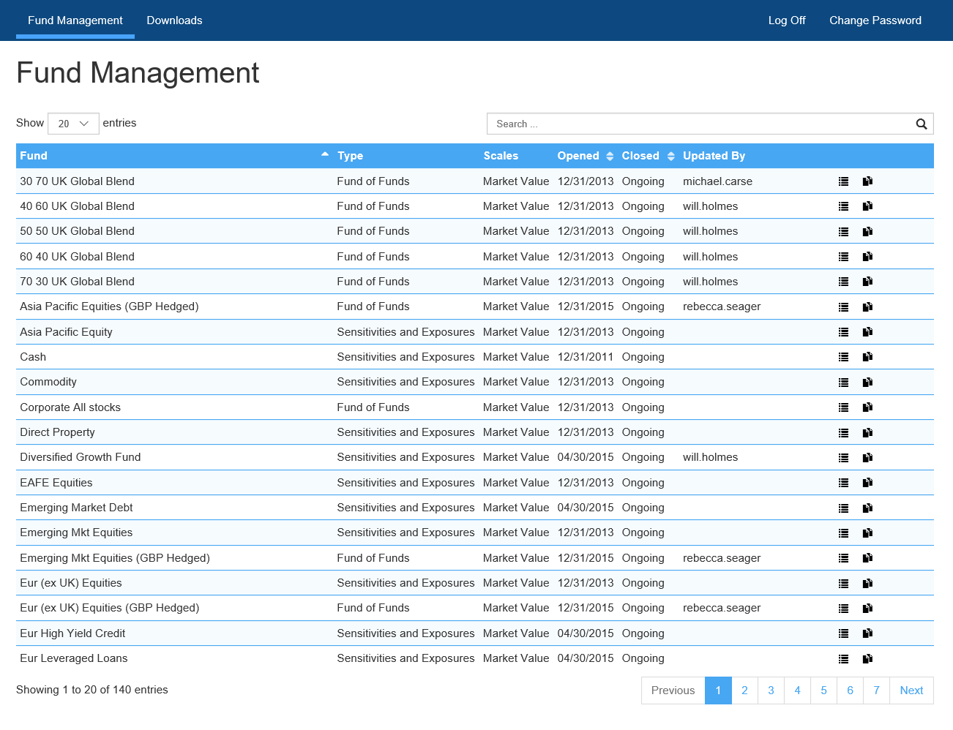The first to greet the user after successfully logging on is the landing page, listing all the funds the user can access. A user may have permission to edit and delete, or just view a fund.

**Tip:** The quickest way to find a specific fund is using the search feature at the top right corner.

### Funds and fund updates

In Fund Manager, a fund in itself is merely a shell containing some basic information about the fund, such as type and currency. The bulk of the information that is likely to change over time is stored in a fund update. For example, the Risk First ‘UK Equities’ proxy fund contains multiple updates as seen below. A fund can only have one active update at a time. An ‘Ongoing’ update will automatically terminate when a more recent update is created.

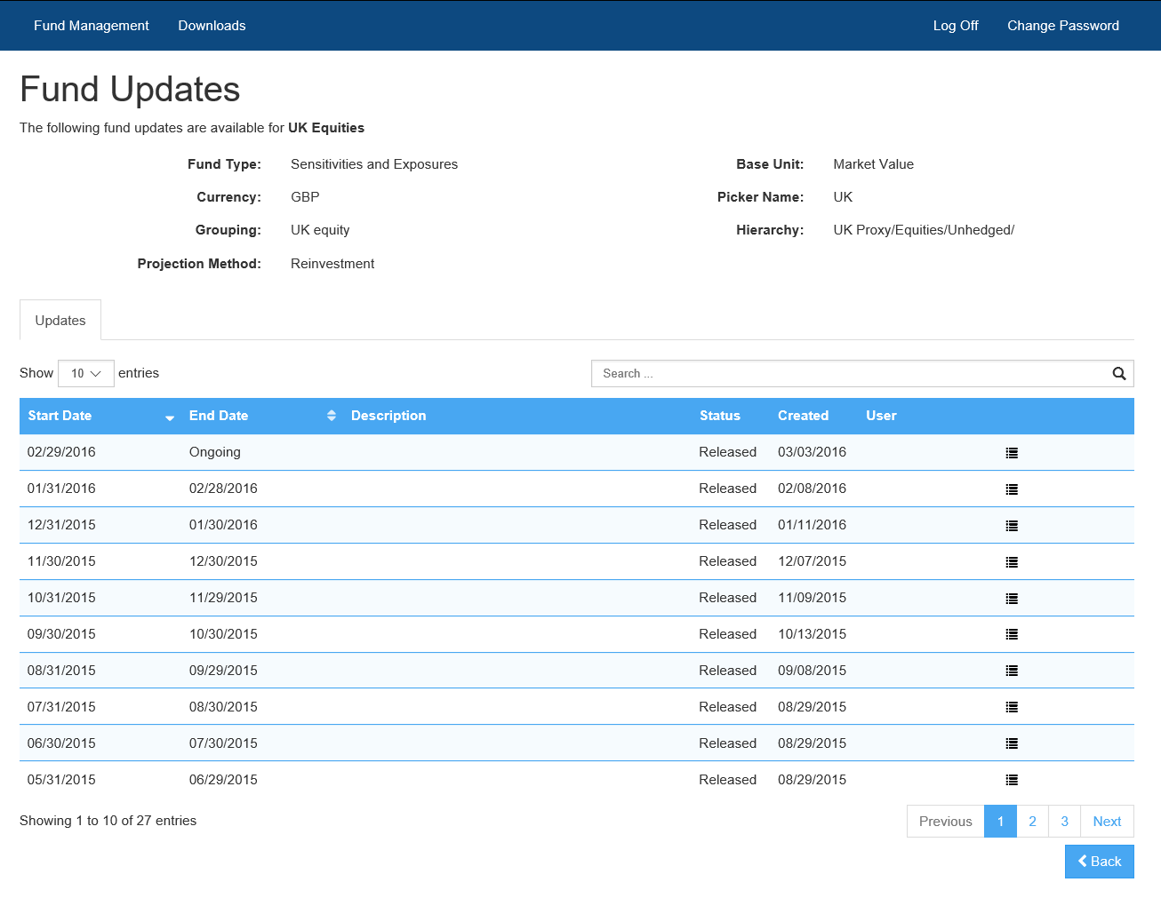

### Fund types

There are several types of funds – Fund of Funds (FoF), Leveraged and Sensitivities & Exposures funds. They all serve a different purpose.

* A **Fund of Funds** is the simplest type, defined by set allocations into one or more existing funds. These can be either Risk First proxy funds, or other user defined funds.
* **Leveraged** funds are Funds of Funds with the addition of leverage bands. The bands control the fund’s leverage ratio.
* **For Fixed Income** portfolios, an alternative way to define a fund is through PV01/IE01/CR01 sensitivity data, or exposure to different risk factors. Both of these methods are available when you create a **Sensitivities & Exposures** fund. Mixing and matching is also possible.

|  |  |  |  |
| --- | --- | --- | --- |
|  | Fund of Funds | Leveraged | Sensitivities & Exposures |
| When | The available Risk First proxy funds are sufficient for your purposes, or you want to combine funds you have previously created | Creating a leveraged fund that has a large negative allocation | Sensitivity data is available |
| Advantages | Simple and straightforward to define  An easy and intuitive way to define leveraged positions | Fund behaviour is ALM is controlled using. | Caters for LDI-type cash flow matching  Can create a mixture of risk factor exposures and sensitivities in one fund |
| Disadvantages | Is limited to the variety of existing funds  Multi-layered Funds of Funds structures may experience performance loss in some modules | Can only be used for market value (as opposed to notional) funds. | Requires more granular data from the user  Risk factor exposures can often be modelled easier through a Fund of Funds  User should be familiar with the related methodology[1] |

# Creating Funds and Updates

## Creating a Fund

To start the fund creation wizard, click the ‘Create Fund’ button in the top right hand corner of the landing page. If the following walkthrough contains terms that you do not understand, please refer to the glossary at the towards of the document.

### Step 1: Fund details

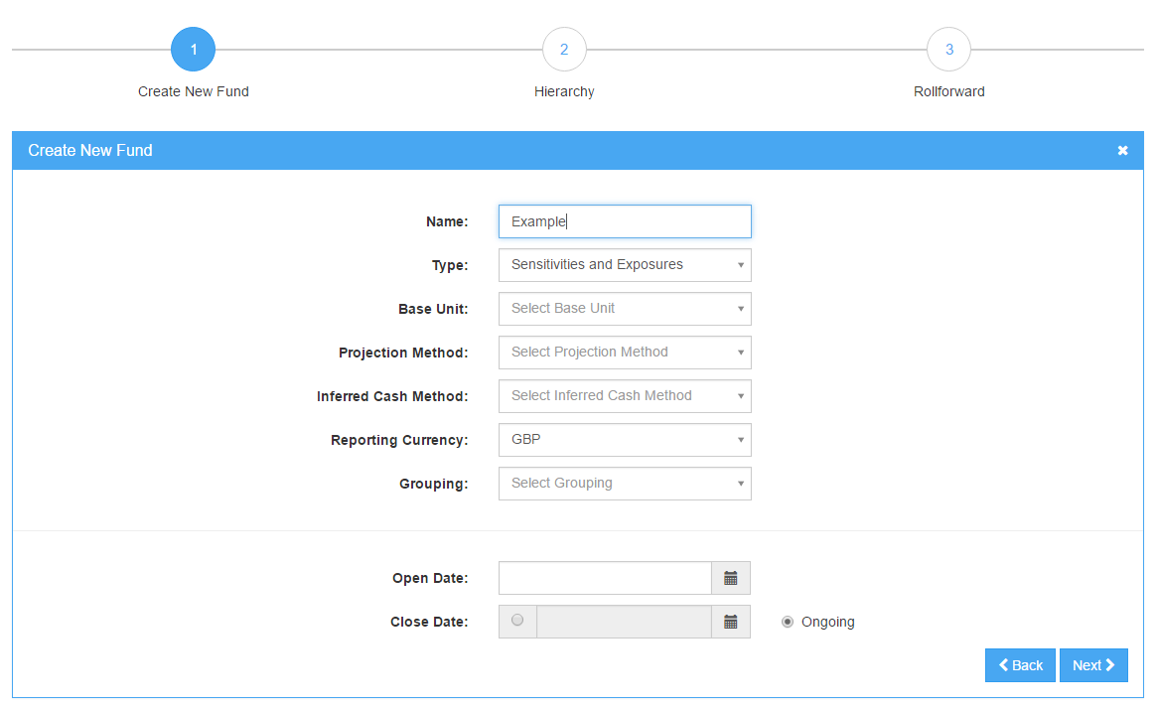

* Details common to all funds:
  + **Name:** This will appear in the ‘Assets’ module.
  + **Type[2]:** Choose one of the available fund types discussed above.
  + **Base Unit: ‘**Market Value’ is appropriate for most assets except derivatives.
  + **Reporting Currency:** This may be pre-selected if only one is available.
  + **Grouping[3]:** Determines for example the attribution under which the fund’s risk appears.
  + **Open Date:** Should be a month end.
  + **Close Date:** Recommended to leave as ‘Ongoing’.
* Specific to Fund of Funds:
  + **Rebalance:** Determines whether the fund adjusts over time to maintain the defined allocation. Rebalancing is appropriate for most situations.
* Specific to Sensitivities & Exposures[4]:
  + **Projection Method:** Defines how the fund’s returns are treated.
  + **Inferred Cash Method:** Determines how the difference between user defined and implied market values is treated.

**Tip:** If you forget one of the definitions above, hovering over a term often displays a helpful tooltip as a reminder.

### Step 2: Hierarchy

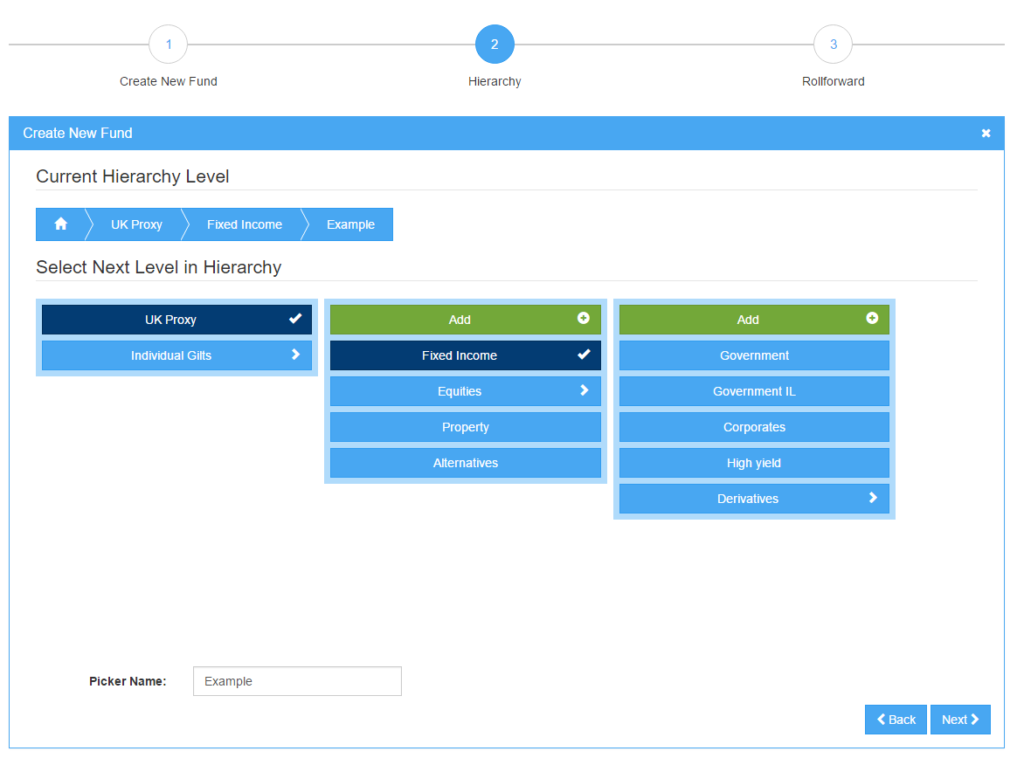

* Common to all funds**:**
  + **Hierarchy:** Determines where the fund will appear in the fund pickers. The hierarchies function like folders, which can contain a number of funds and subfolders. Add new hierarchies to the current hierarchy path with the ‘Add’ button.
  + **Picker name:** How the fund will appear in fund pickers across the system. For example, the ‘Corporate 0-5’ proxy fund has a picker name of ‘0-5’. This is what the fund is called in the What if-modules, and allocations screen.

### Step 3: Roll forward

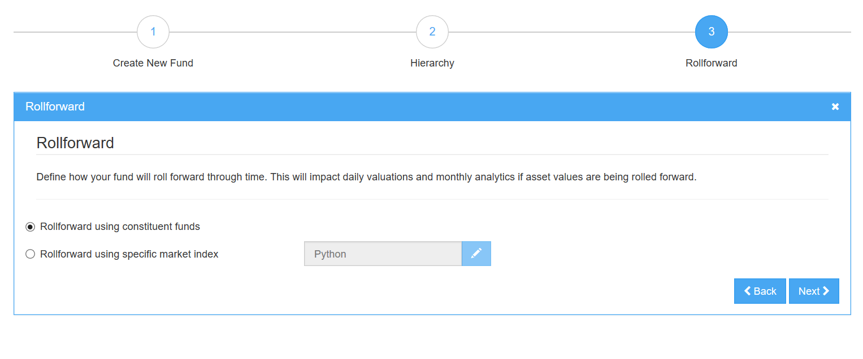

* The roll forward market index drives the fund’s daily values calculation for the dates that lie between fund updates.
* Funds of Funds can also use the weighted average of the constituent funds’ market indices to roll forward.
* Constructing a market index expression:
  + **Example Expression:** Choose one of the examples to use as a template.
  + **Market Index:** Choose one of our available market indices to shoehorn into the example expression.
  + **Check for correctness:** Click ‘Validate’ to confirm that the syntax is correct, and ‘Evaluate’ the expression at a given date to make sure the chosen index is your intended one.
* Alternatively, you can pass ‘1’ as the market index expression. For derivatives, this is the appropriate choice.
* For more information on this, please see the relevant section in this document.

### Step 4: Security context (in some cases)

* If you have the ability to create funds under multiple user groups, choose the relevant one from the dropdown.
* Do not worry if you cannot see this step – this just means your fund will automatically inherit the correct permissions.
* You must now create a fund update for the fund to be available at the desired date.

## Creating a Fund Update

A fund update holds information about the fund that is likely to be adjusted over time. An allocation, sensitivities, and expected returns are examples of the kind of data stored in an update. Updates can be created as frequently as required, although we recommend a monthly or quarterly update cycle. The behaviour of the fund will more accurately reflect reality if the fund is updated regularly.

To create a fund update, navigate to the fund’s update page and click the **Create Update** button. The process differs depending on the fund type.

### Updating a Fund of Funds

* **Setup:**

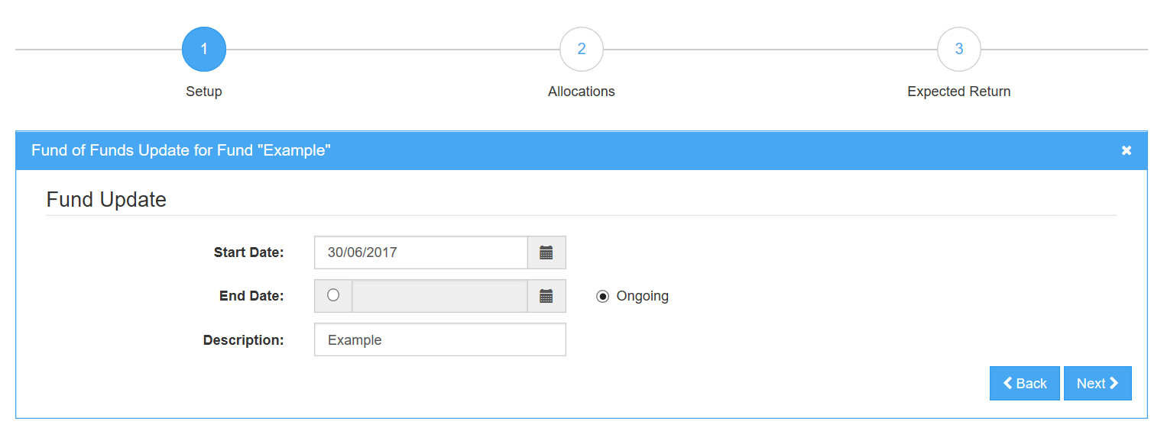

* + Select a **Start Date** and an **End Date** for the update.
  + A **Description** is useful to have, but not mandatory.
* **Select the funds allocations**:

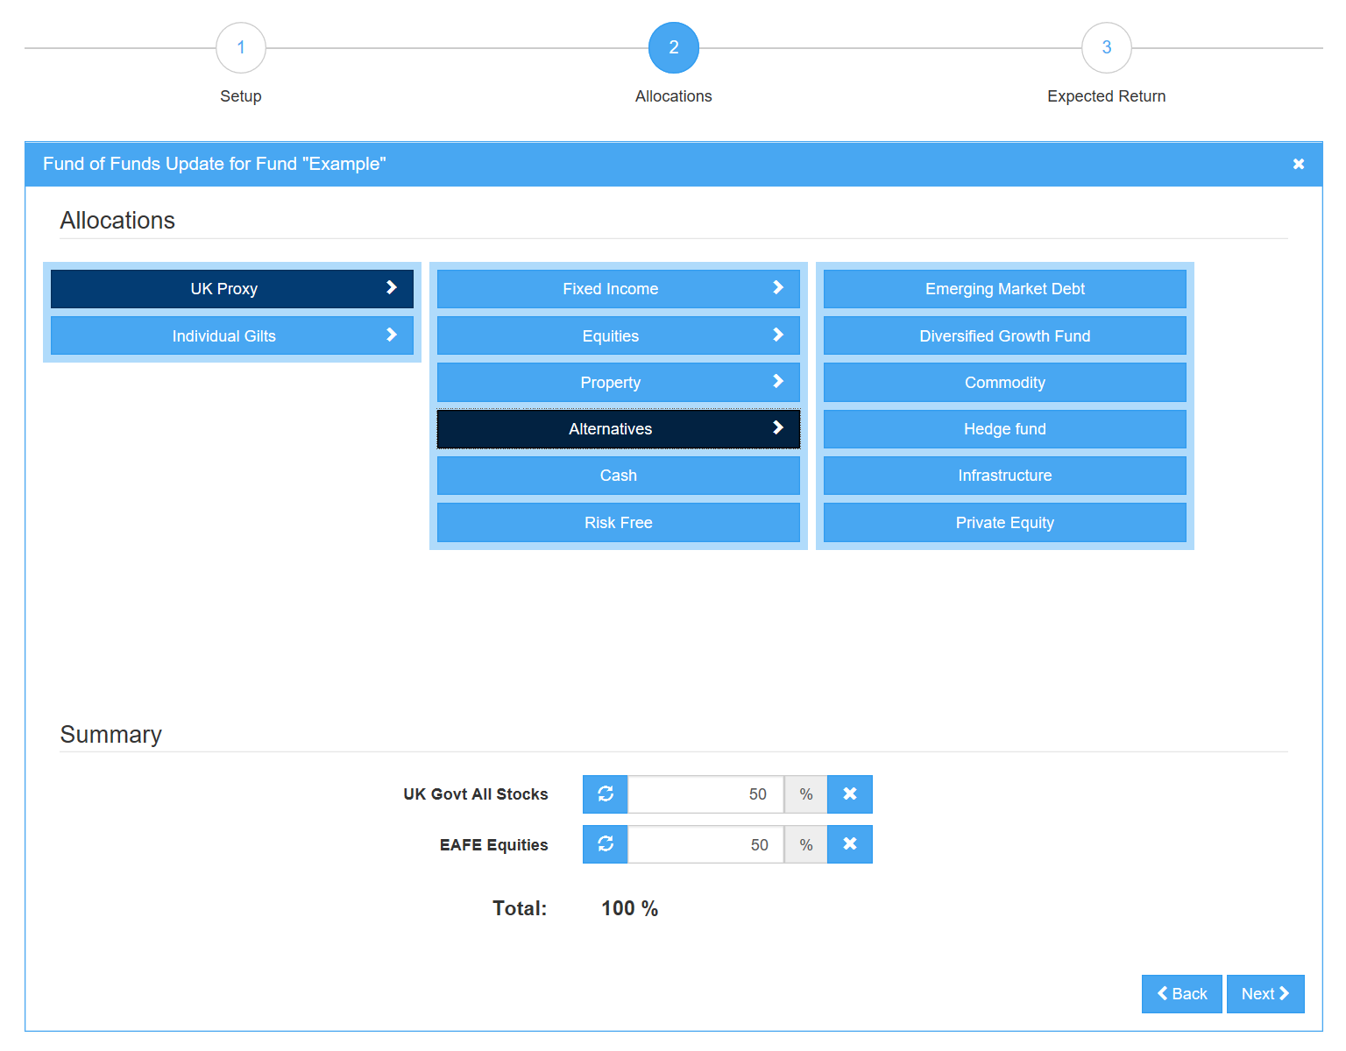

* + Using the fund picker, select the funds that the Fund of Funds is allocated into.
  + Enter the allocation percentage for each constituent fund.
* **Expected return**

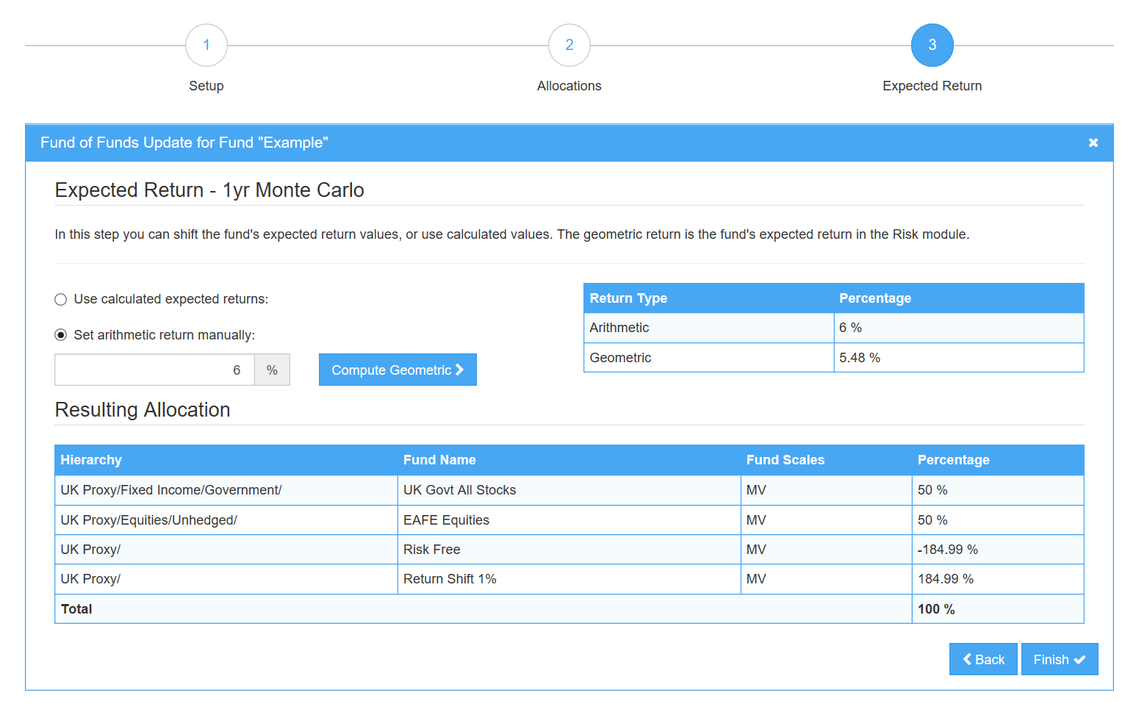

* + You have the option of overriding the fund’s calculated expected return by a value of your own.
  + This functionality is **only** available if your Fund of Funds is set to Rebalance, and the update date is at a month end.
  + If you choose to override the expected return, two additional funds appear to your allocation to make up the difference between calculated and user defined return. These have no other effect on the fund’s behaviour but to add a flat return shift to the fund’s return in both ALM and expected return calculations.
* To be able to allocate into this fund, the update must be released. Please see the Releasing and Deleting Updates and Funds section.

### Updating a Leveraged Fund

Updating a Leveraged fund is very similar to updating a Fund of Funds.

* **Setup:**



* + Select a **Start Date** and an **End Date** for the update.
  + A **Description** is useful to have, but not mandatory.
* **Select the funds allocations**:

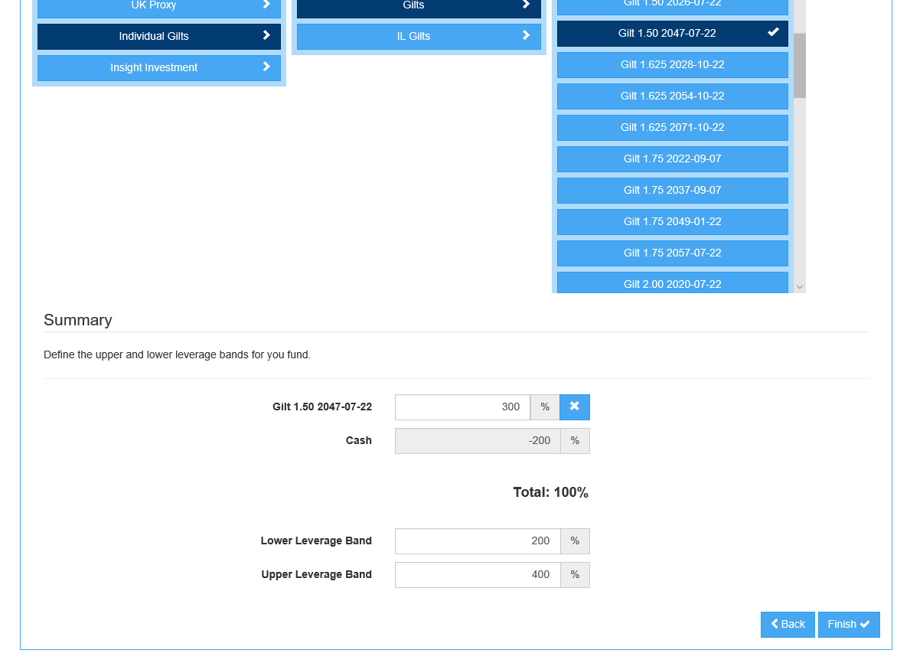

* + Using the fund picker, select a single fund that you would like to leverage.
  + Enter an allocation to that fund. The fund used to leverage your fund must be the Proxy Cash fund.
  + Enter leverage bands. These bands are used in ALM if the leverage ratio of your fund hits one of the bands. For example, suppose a fund has a 300% leverage, with a lower band of 200% and an upper band of 400%. If during an ALM projection the leverage of that fund exceeds 400% or falls below 200%, my fund’s leverage ratio would return to 300% by either adding or releasing cash.
* To be able to allocate into this fund, the update must be released. Please see the Releasing and Deleting Updates and Funds section.

### Updating a Sensitivities Market Value Fund

Sensitivities market value funds can be defined by a set of PV01s, CR01s and IE01s, cashflows or the fund’s market value risk exposure.

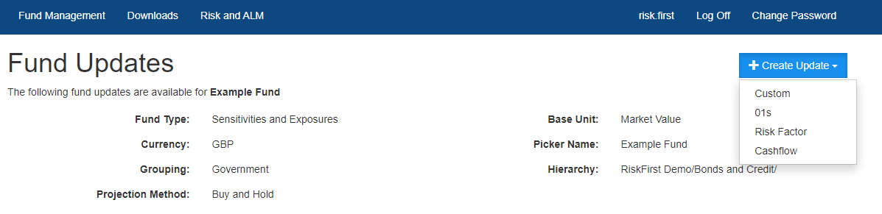

**01s** allow a user to build the framework to define the PV01s, CR01s and IE01s, **Risk Factor** allows users to enter the fund’s market value risk exposure and **Cashflow** allows users to use the cashflow profile of the fund.

### Using 01s to update a Sensitivities Market Value Fund

* **Setup:**

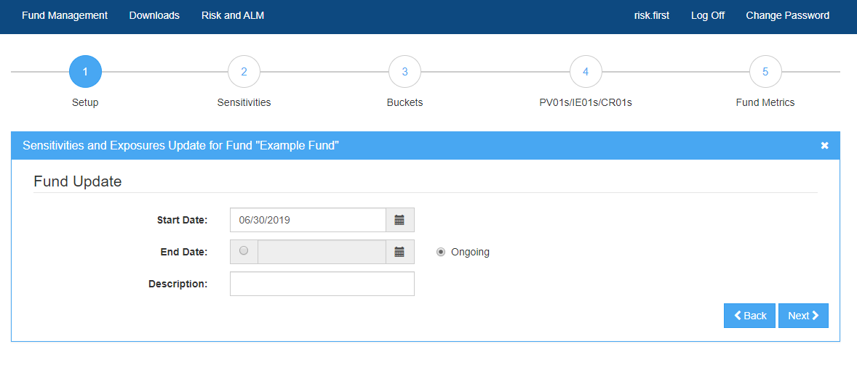

* + Select a **Start Date** and an **End Date** for the update.
  + A **Description** is useful to have, but not mandatory.
* **Sensitivities:**

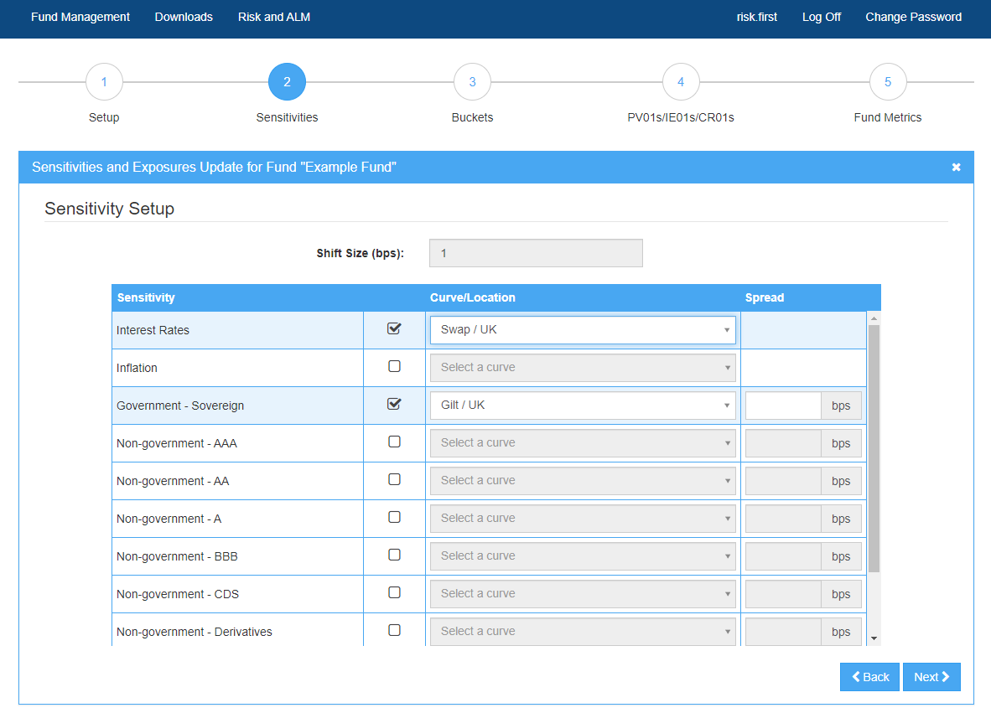

* + Select the types of sensitivities to use, and the risk free curve that each of the sensitivities are calculated off. If your desired risk free curve is not available, please contact [support@riskfirst.com](mailto:support@riskfirst.com).
  + Enter a **Spread** for each credit rating. This is the market value weighted z-spread for that CR01 rating.
* **Buckets:**

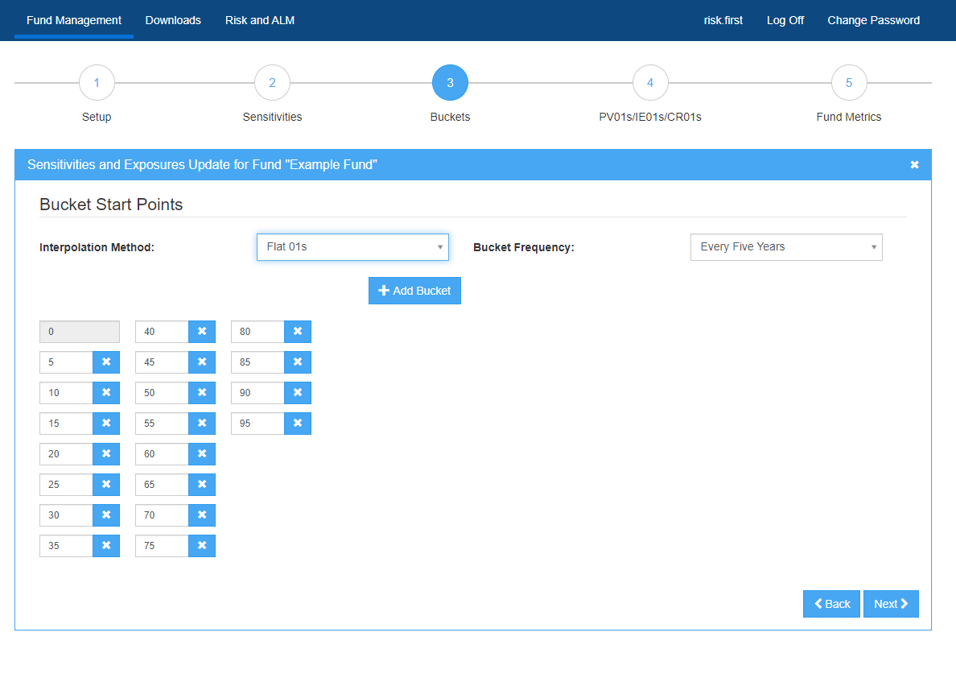

* + Select the start year for each **Bucket**. This specifies the start year of the tenors that are bumped to generate the PV01, CR01 and IE01 data.
  + Choose an **Interpolation method**. This decides how to convert the sensitivities specified into annual cash flows.
  + If you have a standard bucketing method, you can save this as a template for ease of use.
* **PV01s/IE01s/CR01s:**

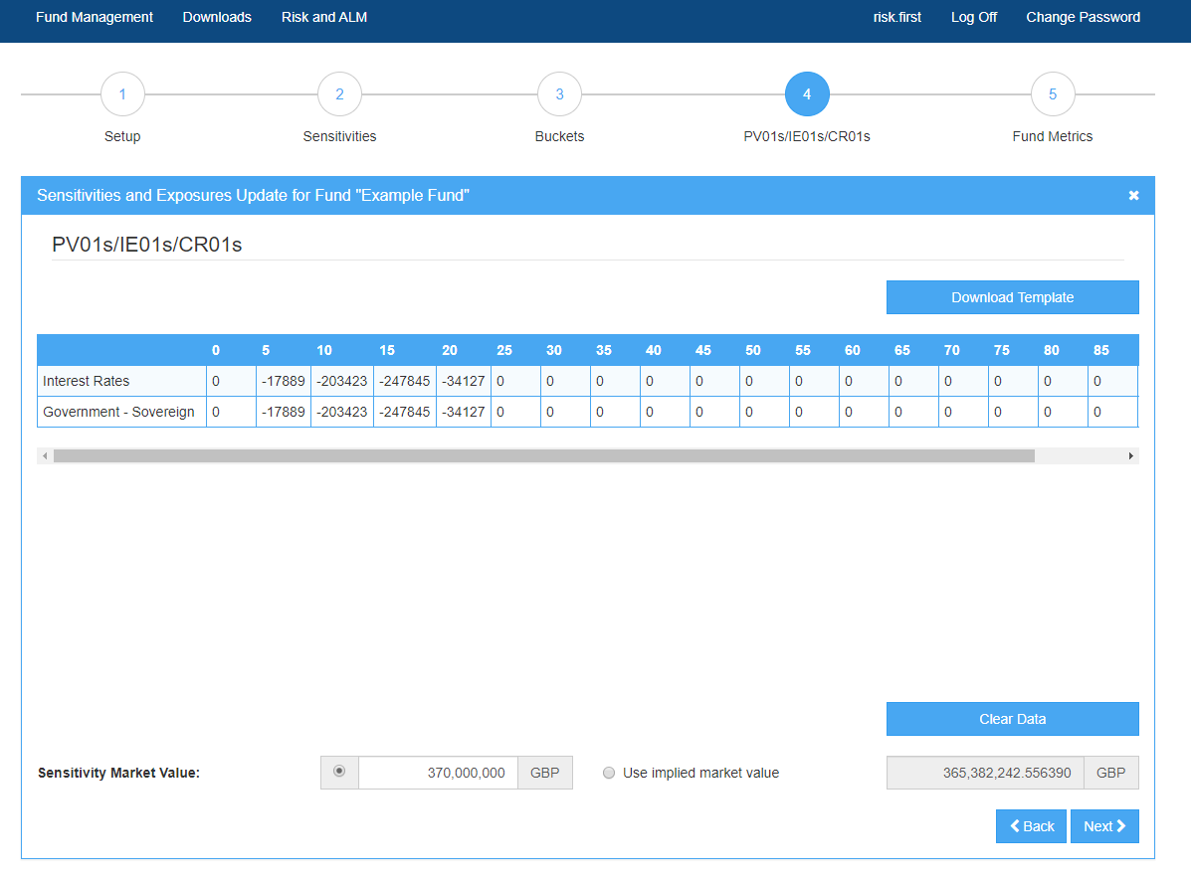

* + **Download** the template. This is generated based on the inputs you have provided in previous steps.
  + Enter the PV01s/IE01s/CR01s into the cells highlighted in grey.
  + **Copy - Paste** the grey area in the template into the designated area in the interface.
  + Enter a **Sensitivity Market Value** associated with the PV01s/IE01s/CR01s.
  + An **Implied Market Value** based on this sensitivity data will display below the pasted data. You can also choose to use this as your Sensitivity Market Value.
* **Fund Metrics:**

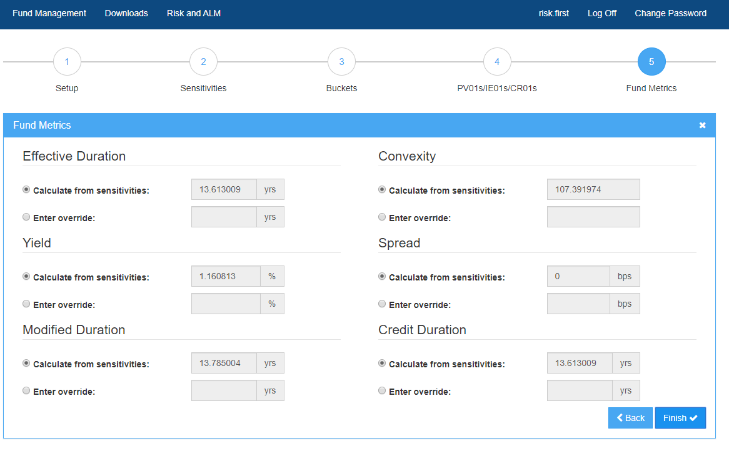

* + These statistics are calculated based on the cash flows implied by the sensitivities. The duration values correspond to the effective duration and effective credit duration of the fund.
  + **The calculations do not take into account any floating cash flows or cash on account.**
  + You can override any or all of these values. This does not change the underlying cash flows but does govern which values are displayed in the Assets module.
  + **To get the metrics for future dates that do not have an update, the cash flows of the fund use the rolled forward with the relevant market index and the future date’s market curves.**
  + **No adjustment is made to account for cash flows being realised over time. This does not cause a material loss of accuracy for the benchmark funds, as these are updated monthly. However, this loss of accuracy may become material if a user only updates their funds seldom, such as quarterly or annually.**
  + **Only the effective duration is supported for Notional type funds, but you can still define an override for all metrics if desired.**

### Using cashflows to update a Sensitivities Market Value Fund

* **Setup:**

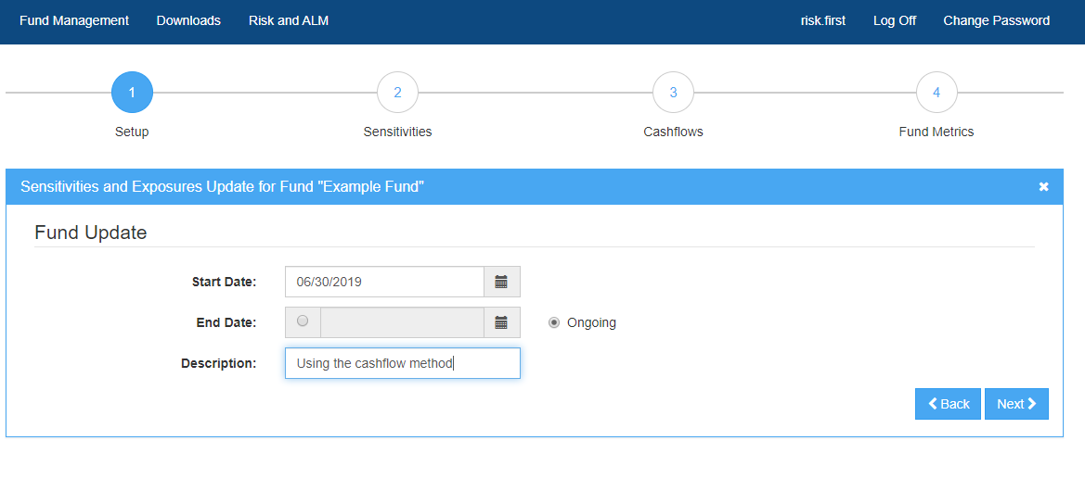

* + Select a **Start Date** and an **End Date** for the update.
  + A **Description** is useful to have, but not mandatory.
* **Sensitivities:** 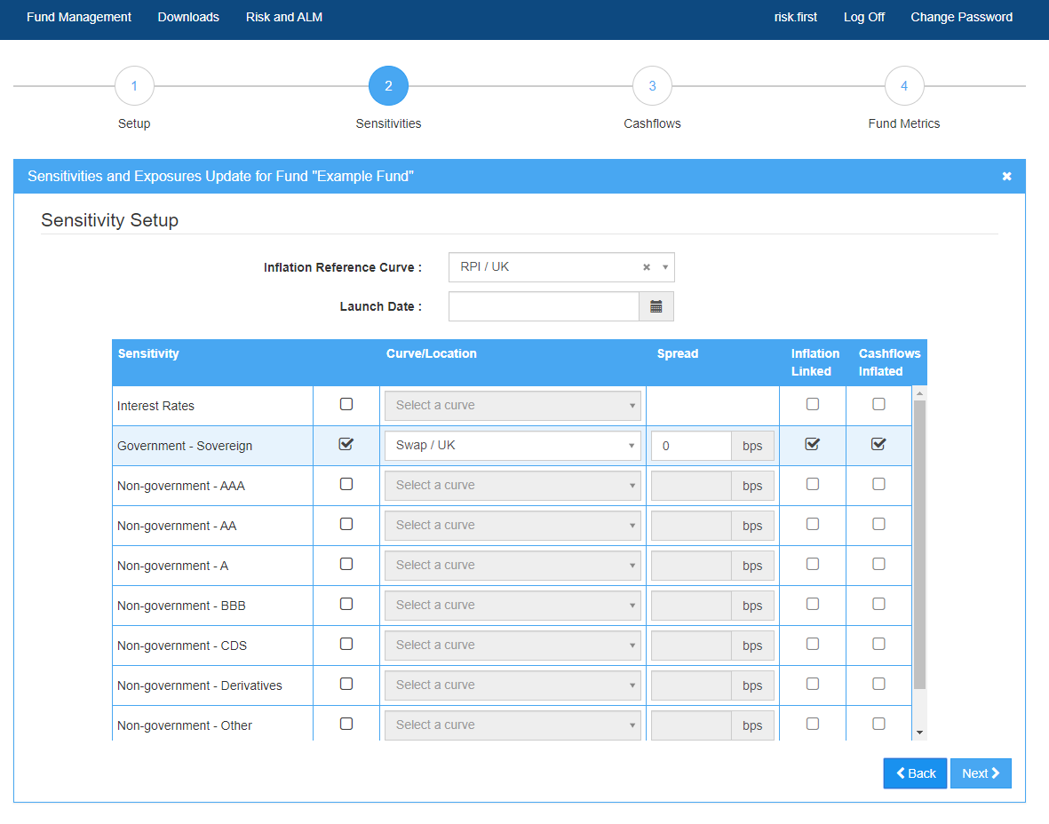
  + Select the types of cashflow to use, and the risk-free curve that the sensitivities will be calculated from.
  + Enter a **Spread** for each credit rating. This is the market value weighted z-spread for that CR01 rating.
  + The Launch Date is the inception date of the fund and is used to inflate your cashflows if they are not inflated. The index corresponding to the inflation reference curve will be used.
* **Cashflows:** 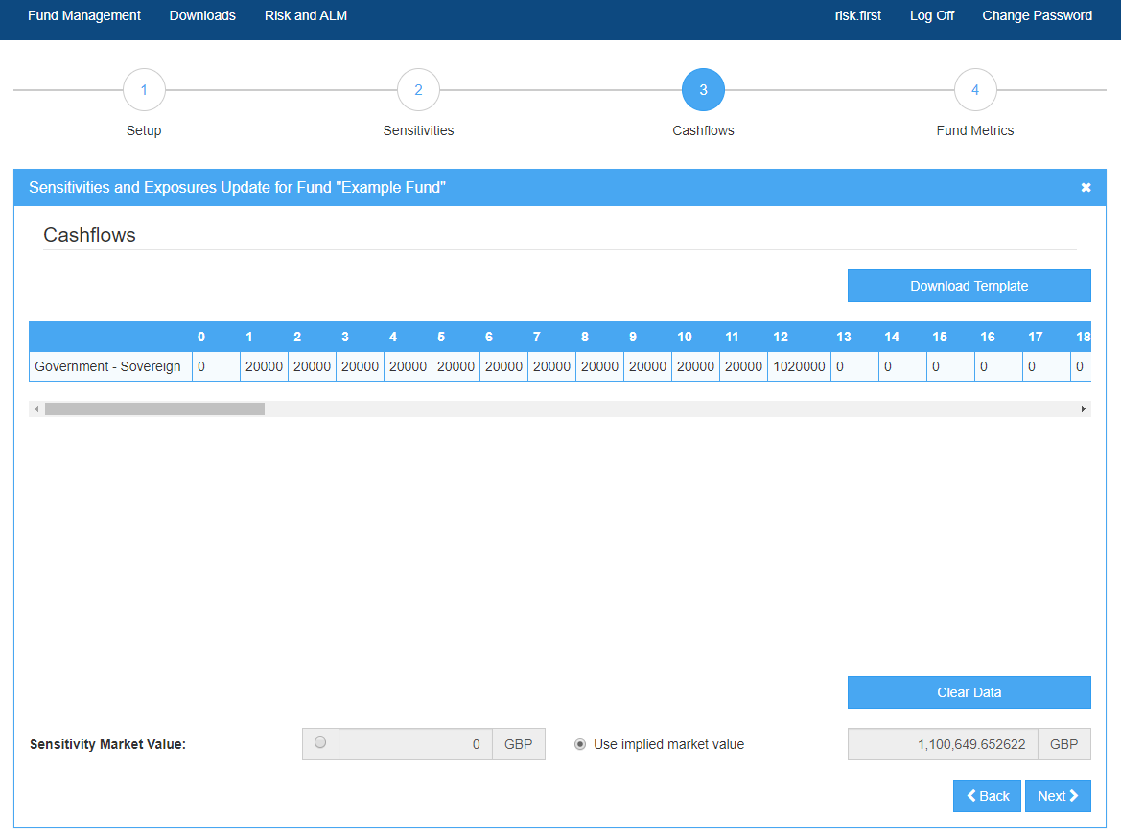
  + **Download** the template. This is generated based on the inputs you have provided in previous steps but will always be annually bucketed.
  + Enter the cashflows into the cells highlighted in grey.
  + **Copy - Paste** the grey area in the template into the designated area in the interface.
  + Enter a **Sensitivity Market Value** associated with the cashflows.
  + An **Implied Market Value** based on this cashflow data will display below the pasted data. You can also choose to use this as your Sensitivity Market Value.
* **Fund Metrics:**

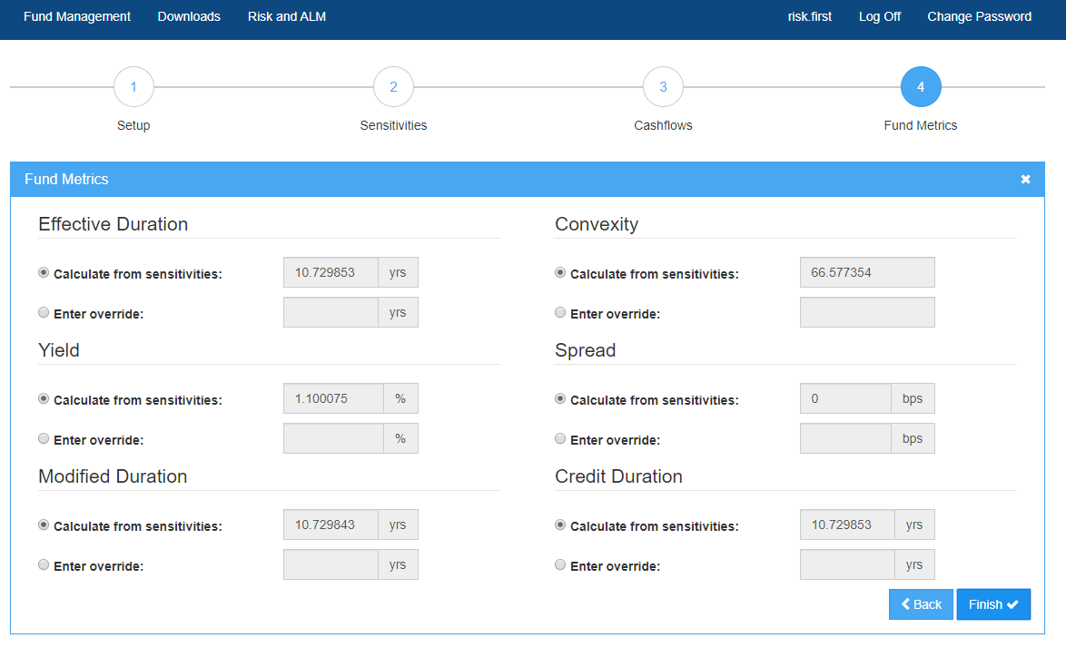

* + These statistics are calculated based on the cash flows implied by the sensitivities. The duration values correspond to the effective duration and effective credit duration of the fund.
  + **The calculations do not take into account any floating cash flows or cash on account.**
  + You can override any or all of these values. This does not change the underlying cash flows, but does govern which values are displayed in the Assets module.
  + **To get the metrics for future dates that do not have an update, the cash flows of the fund use the rolled forward with the relevant market index and the future date’s market curves.**
  + **No adjustment is made to account for cash flows being realised over time. This does not cause a material loss of accuracy for the benchmark funds, as these are updated monthly. However, this loss of accuracy may become material if a user only updates their funds seldom, such as quarterly or annually.**
  + **Only the effective duration is supported for Notional type funds, but you can still define an override for all metrics if desired.**

### Using Risk Factors to update a Sensitivities Market Value Fund

* **Setup:**

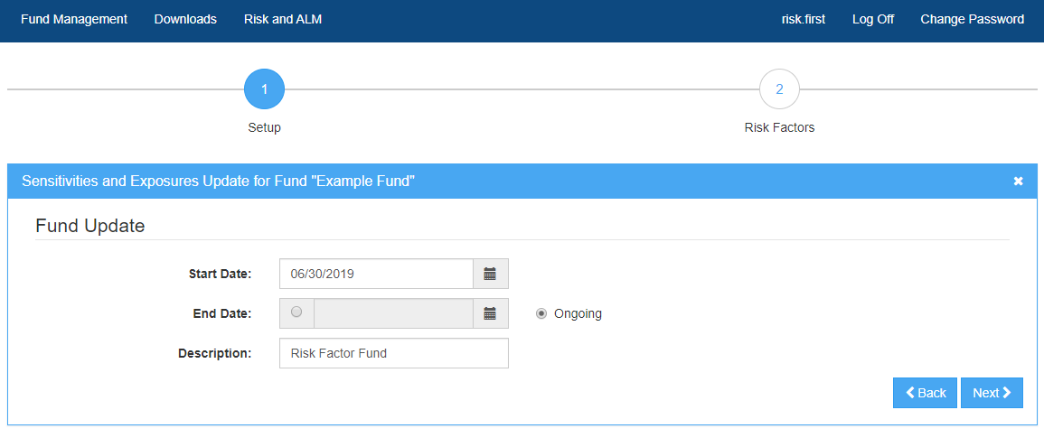

* + Select a **Start Date** and an **End Date** for the update.
  + A **Description** is useful to have, but not mandatory.
* **Risk Factors:**

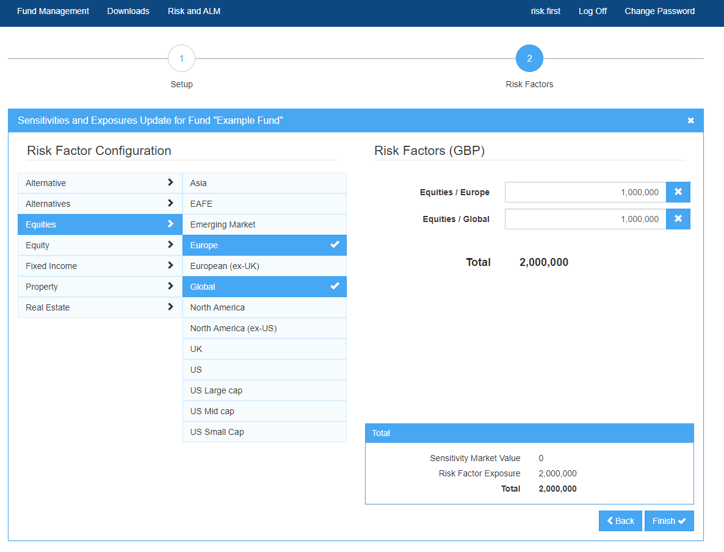

* + Enter the market value exposed to each risk factor.
  + Users can select multiple risk factors for one fund

### Updating a Derivative

* The steps are identical to a market value fund except for two differences in the **PV01s/IE01s/CR01s** step
  + The **Sensitivity Market Value** corresponds to the market value of the fund given the amount entered in the notional field below is allocated to the fund. For example, the sensitivity market value of a benchmark swap at initiation is 0.000001.
  + Enter a value in the **Notional** field. This is value that the fund’s PV01s/IE01s/CR01s are based on.

### Multi-fund Updates

* Multiple Funds can be updated easily via the **Multi-Fund Update** feature. To start a multi-fund update, click the corresponding button found on Fund Manager landing page.
* Setup
  + Select a **Start Date** and an **End Date** for the updates. These need to be the same for all fund updates.
  + Select the funds you wish to update through the fund picker.
  + Click **Download Templat**e once you have selected your funds.
* Template
  + Fill in the grey fields in the Excel template. Note that different fund types are found on separate worksheets.
  + Once filled in, save the template and upload it to Fund Manager by choosing the **Upload** option on the Multi-Fund Update page.
* Releasing Updates
  + A successful upload will take you to the release step. You can view and release single updates, or release all updates by clicking the corresponding buttons.

# Releasing and Deleting Updates and Funds

When you create an update it has a **Pending** status. If an update has a pending status, it is unavailable until released. To release a fund, click the release icon  to the right of the update.



Once a fund has been released it can be seen immediately in the following modules:

* Asset allocations
* Assets
* Combined
* All dashboard quadrants except the VaR quadrant
* Optimizer, excluding the ‘Risk and Returns’ tab
* Deterministic ALM

The fund will appear in Risk and Stochastic ALM with a slight delay. Please allow approximately 30 minutes for the Risk and Stochastic ALM data to calculate. The exact time taken depends on where your fund is in the calculation queue.

Updates can be **Unreleased** by clicking the unrelease icon , which will have replaced the release icon. This may be necessary if you wish to edit a fund after it has been released. If an update is being used in an allocation and the update is unreleased, the valuation will no longer will no longer be valid. This is characterised by the fund being shown in the allocation module in an unavailable state.



If you unrelease and delete an update that is being used by an allocation, the valuation will have no value. In the allocation module you will have an ‘Unknown’ item.

You cannot delete funds that have released update in them. If you would like to delete such a fund, you must unreleased all of the updates and then delete the fund.

We recommend that you exercise extreme caution when unreleasing and deleting funds given the possible impact to plan allocations.

# Typical fixed income modelling (including derivatives)

* The table below summarises how typical fixed income asset classes would be effectively described by the PFaroe Asset Modelling Framework.
* The input sensitivities (x, y, z) infer cashflows (X, Y, Z) without explicit knowledge of the asset class. Reuse of the same symbol for a given row in the table indicates the sensitivity or cashflows are of similar magnitude (e.g. a credit risky bond where CR01 = PV01).
* The choice of Cash on Account or Floating Leg affects (a) the display of cashflows in the asset analytics and (b) generation of cashflows in ALM projections. The choice of Transport method affects how the cashflows change in time in ALM projections.

|  |  |  |  |  |  |  |  |  |  |
| --- | --- | --- | --- | --- | --- | --- | --- | --- | --- |
| **Asset class** | **Sensitivities** | | | **Cashflows** | | | **Cash on Account or Floating Legs?** | **Transport method** | |
| Risk free rates | Inflation | Credit | Risk free | Real | Credit | Buy and Hold | Reinvestment |
| Fixed coupon bonds (risk free, including government)) | x |  |  | X |  |  | - | Yes | Yes |
| Fixed coupon bonds (credit risky) | x |  | x |  |  | X | - | Yes | Yes |
| Inflation-linked bonds (risk free) |  | x |  |  | X |  | - | Yes | Yes |
| Inflation-linked bonds (credit risky) | x | x | x[5] | -X | X | X | - | Yes | Yes |
| Floating rate notes (FRNs) |  |  | x | -X |  | X | Floating leg | Yes | Yes |
| Asset Backed Securities (ABS)[6] | X |  | x |  |  | X | - | Yes | Yes |
| Credit Default Index (CDX) | y<<x[7] |  | x | Y |  | X | Cash on Account | Yes | Yes |
| Credit Default Swaps (CDS)[8] | y<<x |  | x | Y |  | X | Cash on Account | Yes | Yes |
| Interest rate swap | x |  | x | X |  |  | Floating leg inferred of approximately equal magnitude to fixed leg | Yes | No |
| Inflation swap |  | x |  | -X | X |  | - | Yes | No |
| Bond futures[9] | x |  |  | X |  |  | Large negative Cash on Account position creates leverage | No | Yes |
| Total Return Swaps (TRS)[10] | x | x | x | X | X | X | Floating legs create leverage | No | Yes |
| Repos | x | x | x | X | X | X | Floating legs create leverage | No | Yes |
| FX Forwards[11],[12] |  |  |  |  |  |  |  | No | Yes |
| Asset swaps |  |  | x | -X |  | X | Floating legs create leverage | Yes | No |
| Loans[13] |  |  |  |  |  |  | Cash on Account | No | X |

# FAQs

* I’m stuck – what should I do?
  + First check this user guide
  + Email [PFaroeSupport@Moodys.com](mailto:PFaroeSupport@Moodys.com)
* I don’t understand how the cash flows of my fund are calculated.
  + Please see [Asset Modelling Framework Methodology](http://docs.pfaroe.com/setting-up-pfaroe/detailed-reference-guides/risk-alm-methodology-guide/) for a technical overview.
* Where will I see my fund?
  + When the fund has a release update, you can allocate to it in the asset allocation screen and What if –tools.
* My fund has appeared in fund pickers, but is unavailable.
  + Check that the fund has an updated release at the date you are trying to allocate.
  + If you have used the bullet interpolation method, the 01 data that you have entered into the tenor 0 must be 0.
  + Risk and ALM data takes some time to calculate. If the fund is available elsewhere, please allow some time for the calculations to finish.
* The expected return I defined does not match what I see in the Risk module.
  + After defining your arithmetic return in the Expected Return step, click the **Compute Geometric** button. The number displayed as the geometric return is the number you will see in the **Risk** module.
* What are the next stages of development?
  + Usability improvements
  + Expanded features in the alternatives space
  + User feedback
* What if a market index I want isn’t available?
  + Contact support with the index code of the desired index. If the index data is available to us, we do our best to cater for any requests.
* What if a risk factor I want isn’t available?
  + Contact [PFaroeSupport@Moodys.com](mailto:PFaroeSupport@Moodys.com)
* I try to make a multi-fund update but nothing happens when I upload the filled template.
  + Some browsers have problems with the Multi-Fund Update feature. Try using one of our supported browsers.
* How can I override yield, spread and duration values of an existing fund update?
  + You can unrelease the fund and edit the fund update. If there are many such funds, our Support team will be able to efficiently update these for you.

# Glossary

### Much of the terminology used in Fund Manager is business standard, but some are specific to our models. Please find below a list of the key terms used throughout the site.

### Creating a Fund

* Fund types:
  + **Fund of Funds (“FoF”):** Aggregations of existing funds. The weights to each fund can be customised.
  + **Leveraged:** A Fund of Funds with leverage bands. The fund returns to the original leverage ratio if a leverage band is hit in ALM.
  + **Sensitivities and Exposures:** These funds are defined by their sensitivities to interest rates, inflation rates, credit yields, and by effective notional exposures to a range of market indices.
* Base unit:
  + **Market values:** Allocations are made to the fund in terms of market value amounts, in contrast to,
  + **Notional:** Allocations are made to the fund in terms of a notional currency amount. This is usually the case for derivatives (e.g. swaps, futures) where the market value is usually small (or possibly zero) and so an allocation in terms of market value is not meaningful.
* Projection Method:
  + **Buy and Hold:** Assets are held until the last cashflow is realised. This causes the duration of the fund to shorten. Please note that despite the identical nomenclature, this is different from the Buy and Hold allocation strategy in the ALM module.
  + **Reinvestment:** Assets are held for a unit of time and the return is calculated. The fund’s duration stays constant through time.
* Inferred Cash Mode:
  + **Cash on Account:** The difference between user defined market value and implied market value is captured by a single cash amount.
  + **Floating Cashflow:** The difference between user defined market value and implied market value is captured by cashflows that match the cashflow profile of the sensitivities.
* **Grouping:** Determines what category the fund should belong to for aggregation with other funds in various reports, charts, displays, and other elements of the UI
* **marketDataService.GetMarketIndex(‘INDEX CODE’, valuationDate):** The Python expression that should be used if the index you would like to track is in the same currency as your fund.
* **marketDataService.GetMarketIndexInReportingCurrency(‘INDEX CODE',currency,valuationDate):** The Python expression that should be used if the index you would like to track is not in the same currency as your fund.

**Updating a fund**

* **Shift size:** The size of the shift which was used to determine the sensitivities. For example, 1 basis point.
* **Implied market value:** The present value of the cashflows implied by the set of user provided sensitivities.
* Interpolation methods:
  + **Bullet:** The cashflow inferred from the sensitivity will be placed exactly at the tenor where the sensitivity is entered. This is useful for bullet-like instruments, or where the sensitivity and cashflow structure are precisely known (such as swaps or single zero coupon bonds and ‘STRIPS’).
  + **Flat 01s:** For sensitivities spanning multiple tenors (a bucket), the sensitivity is assumed equal over each of the tenor by dividing the sensitivity for the bucket by the width of the bucket. This tends to generate a series of downward sloping cashflows within the bucket (as the duration of the tenors increase within the bucket).
* Sensitivity type:
  + **Square Shift PV01s:** The sensitivities entered correspond to shifting the corresponding rate or yield curve uniformly upwards (by the “Shift size” parameter).
* **Sensitivity market value:** Enter the total market value of instruments which generated the sensitivities provided.
* **Notional:** Enter the notional market value of instruments which generated the sensitivities provided.
* **PV01:** Sensitivity to changes in risk free interest rates.
* **CR01:** Sensitivity to changes in credit yields.
* **IE01:** Sensitivity to changes in inflation expectation rates.
* **Spread:** Spread appears in two contexts when creating a sensitivities fund update. Firstly, a user inputs a parallel spread to the fund’s risk free curve for each set of CR01s. An aggregate z-spread to the risk free curve is calculated at the end of the update as the value that discounts the aggregate cash flows to the implied market value.
* **Yield:** The yield of a sensitivities fund is the value that discounts the aggregate cash flows of the fund to the implied market value.
* **Effective Duration:** The effective duration of a sensitivities fund is calculated as:  
  where the market values correspond to the fund market value assuming a 1bps shift in rates down or up respectively, and the unstressed fund market value.

# Groupings

The Grouping of a fund determines how funds are aggregated in different asset classes.

|  |  |  |  |  |
| --- | --- | --- | --- | --- |
| Grouping | Asset Class |  | Grouping | Asset Class |
| Absolute Return | Fixed Income |  | High Yield | Fixed Income |
| Alternatives | Alternatives |  | High Yield Long | Fixed Income |
| Asian Equity | Equity |  | High Yield Medium | Fixed Income |
| Bond Future | Fixed Income |  | High Yield Short | Fixed Income |
| Cash | Cash |  | High Yield Ultra Long | Fixed Income |
| CDS | Fixed Income |  | Inflation LDI | Fixed Income |
| Commodities | Alternatives |  | Inflation Swap | Fixed Income |
| Corporate | Fixed Income |  | Infrastructure | Alternatives |
| Corporate A | Fixed Income |  | Interest Rate Swap | Fixed Income |
| Corporate AA | Fixed Income |  | Loan funds | Fixed Income |
| Corporate AAA | Fixed Income |  | Multi-Asset Credit | Fixed Income |
| Corporate BBB | Fixed Income |  | Multi-Asset Fund | Alternatives |
| Corporate Long | Fixed Income |  | Nominal LDI | Fixed Income |
| Corporate Medium | Fixed Income |  | North American Equity | Equity |
| Corporate Short | Fixed Income |  | Other | Other |
| Corporate Ultra Long | Fixed Income |  | Private Equity | Alternatives |
| DGF | Alternatives |  | Property | Property |
| EAFE Equity | Equity |  | Real Estate | Real Estate |
| Emerging market debt | Alternatives |  | Real LDI | Fixed Income |
| Emerging Market Equity | Equity |  | REIT | Property |
| Equity | Equity |  | STRIPS | Fixed Income |
| Equity Index Future | Equity |  | STRIPS Long | Fixed Income |
| Equity Index Option | Equity |  | STRIPS Medium | Fixed Income |
| Equity-Linked Bonds | Fixed Income |  | STRIPS Short | Fixed Income |
| Equity-Linked LDI | Fixed Income |  | STRIPS Ultra Long | Fixed Income |
| European Equity | Equity |  | Swaption | Fixed Income |
| Fixed Income | Fixed Income |  | TIPS | Fixed Income |
| FX Forward | Fixed Income |  | TIPS Long | Fixed Income |
| Global Equity | Equity |  | TIPS Medium | Fixed Income |
| Government | Fixed Income |  | TIPS Short | Fixed Income |
| Government IL | Fixed Income |  | TIPS Ultra Long | Fixed Income |
| Government IL Long | Fixed Income |  | Total Return Swap | Fixed Income |
| Government IL Medium | Fixed Income |  | Treasuries | Fixed Income |
| Government IL Short | Fixed Income |  | Treasuries Long | Fixed Income |
| Government IL Ultra Long | Fixed Income |  | Treasuries Medium | Fixed Income |
| Government Long | Fixed Income |  | Treasuries Short | Fixed Income |
| Government Medium | Fixed Income |  | Treasuries Ultra Long | Fixed Income |
| Government Short | Fixed Income |  | UK Equity | Equity |
| Government Ultra Long | Fixed Income |  | US Equity | Equity |
| Hedge Fund | Alternative |  | Unknown | Unknown |

# Disclaimer

This document contains proprietary information that is confidential, constitutes intellectual property of Risk First Group Limited or an affiliate (**Risk First**) and may be subject to legal privilege. If you have a confidentiality or non-disclosure agreement with Risk First, this document constitutes confidential information of Risk First. You may not copy or distribute this document or any information contained in it to any other person except as required by law, regulation or appropriate court order or by written agreement from Risk First. Although reasonable care has been taken by Risk First to ensure that the facts stated, opinions given and projections made in this document are fair and accurate, no representation or warranty, express or implied, is made as to, and no reliance should be placed on, the fairness, accuracy or completeness of the information, opinions, estimates or projections contained in this document. Neither Risk First nor any other person accepts any liability for any loss arising from any use of this document or its contents or otherwise. The information and/or recommendations contained in this document are given as at its date of publication and are subject to change without notice. This document is not an offer for sale, invitation to treat or subscription of or solicitation of any offer to buy or subscribe for any securities nor shall it form the basis of or be relied on in connection with or act as an inducement to enter into any contract or commitment. Risk First is not acting on your behalf and will not be held responsible for providing you protection in this matter.

1. See [Asset Modelling Framework Methodology](http://docs.pfaroe.com/setting-up-pfaroe/detailed-reference-guides/risk-alm-methodology-guide/) for more information
2.
3. You can find a list grouping to asset class mappings towards the end of this document
4. See [Asset Modelling Framework Methodology](http://docs.pfaroe.com/setting-up-pfaroe/detailed-reference-guides/risk-alm-methodology-guide/) for more information
5. Credit risk for inflation-linked bonds is modelled as an overlay of credit-risky, non-inflation-linked cashflows
6. Inferred notionals and cashflows reflect notionals already paid down
7. CDS, CDX show a very small amount of interest rate sensitivity
8. Effectively equivalent to CDX treatment; no specific payouts on individual default events are accommodated
9. Rolling contracts assumed
10. Rolling contracts assumed
11. Long/short cash positions in two economies
12. Rolling contracts assumed
13. Rolling contracts assumed